Binomial Distribution:

It is simply the probability of success/ failure of outcomes in experiment/ survey that is repeated multiple times. It is also closely related to Bernoulli distribution.

“If each Bernoulli trail is independent, then the no. of success in Bernoulli trial has a Binomial distribution.

Otherwise, Bernoulli distribution is a Binomial distribution with n= 1.”

Criteria-

* No. of observations/ trials is fixed.
* Each observation/ trial is independent
* Probability of success is exactly same from one trail to another.

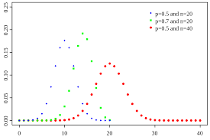

[binomialprobabilityformula](https://www.statisticshowto.datasciencecentral.com/wp-content/uploads/2009/09/binomialprobabilityformula1.bmp)

Bernoulli Distribution:

It is a discrete probability distribution for a Bernoulli trial- a random experiment that has only two outcome (Success/ Failure). In simple words, it is a binomial distribution with single trial.

[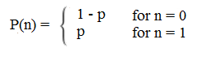](https://www.statisticshowto.datasciencecentral.com/wp-content/uploads/2016/07/pdf-bernoulli.png)

Probability (Failure)=0

Probability (Success)=1

[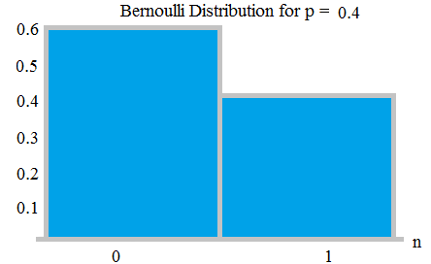](https://www.statisticshowto.datasciencecentral.com/wp-content/uploads/2016/07/bernoulli-distribution.png)

Geometric Distribution:

Represents the number of failures before you get a success in a series of Bernoulli trails. This discrete probability distribution is represented by the probability density function:

**f(x) = (1 − p)**x − 1**p**

*For example, you ask people outside a polling station who they voted for until you find someone that voted for the independent candidate in a local election. The geometric distribution would represent the number of people who you had to poll before you found someone who voted independent. You would need to get a certain number of failures before you got your first success.*

*If you had to ask 3 people, then X=3; if you had to ask 4 people, then X=4 and so on. In other words, there would be X-1 failures before you get your success.*

[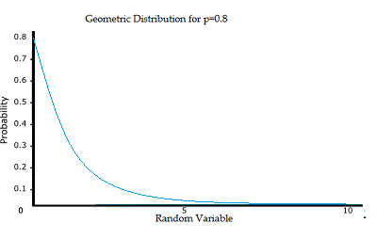](https://www.statisticshowto.datasciencecentral.com/wp-content/uploads/2015/05/geometric-distribution.png)

The three assumptions are:

* There are two possible outcomes for each trial (success or failure).
* The trials are independent.
* The probability of success is the same for each trial.

Poisson Distribution:

A Poisson distribution is a tool that helps to predict the probability of certain events from happening when you know how often the event has occurred. It gives us the probability of a given number of events happening in a fixed interval of time.

For example- A textbook store rents an average of 200 books every Saturday night. Using this data, you can predict the probability that more books will sell (perhaps 300 or 400) on the following Saturday nights.

Because of this application, Poisson distributions are used by businessmen to make forecasts about the number of customers or sales on certain days or seasons of the year. In business, overstocking will sometimes mean losses if the goods are not sold. Likewise, having too few stocks would still mean a lost business opportunity because you were not able to maximize your sales due to a shortage of stock.

Multinomial Distribution:

The multinomial distribution is used to find probabilities in experiments where there are more than two outcomes. A multinomial experiment is almost identical with one main difference: a binomial experiment can have two outcomes, while a multinomial experiment can have multiple outcomes.

Example: You roll a die ten times to see what number you roll. There are 6 possibilities (1,2,3,4,5,6), so this is a multinomial experiment. If you rolled the die ten times to see how many times you roll a three, that would be a binomial experiment (3 = success, 1,2,4,5,6 = failure).

A binomial experiment will have a binomial distribution. A multinomial experiment will have a multinomial distribution.

[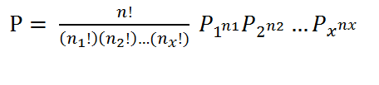](https://www.statisticshowto.datasciencecentral.com/wp-content/uploads/2015/05/multinomial-formula-2.png)

Negative Binomial Distribution:

It is almost the same as a binomial experiment with one difference: a binomial experiment has a fixed number of trials. A negative binomial distribution (also called the Pascal Distribution) is a discrete probability distribution for random variables in a negative binomial experiment.

If the following five conditions are true the experiment is binomial:

* Fixed number of n trials.
* Each trial is independent.
* Only two outcomes are possible (Success and Failure).
* Probability of success (p) for each trial is constant.
* A random variable Y= the number of successes.

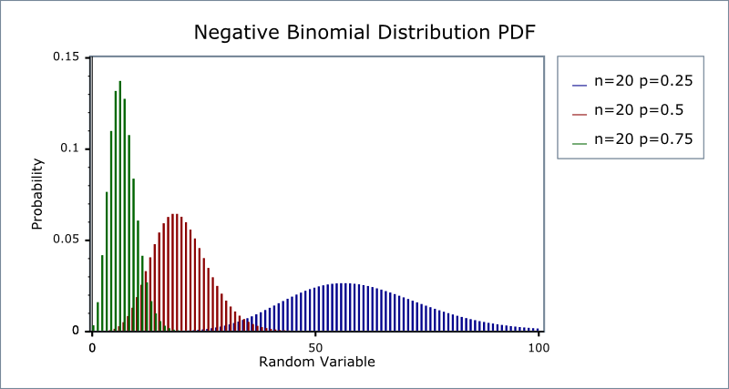

The negative binomial is similar to the binomial with two differences (specifically to numbers 1 and 5 in the list above):

* The number of trials, n is not fixed.
* A random variable Y= the number of trials needed to make r successes.

Example: Take a standard deck of cards, shuffle them, and choose a card. Replace the card and repeat until you have drawn two aces. Y is the number of draws needed to draw two aces. As the number of trials isn’t fixed (i.e. you stop when you draw the second ace), this makes it a negative binomial distribution.